[Latest update here](https://github.com/Angel-125/MOLE/releases)  
  
Placeholder images:  
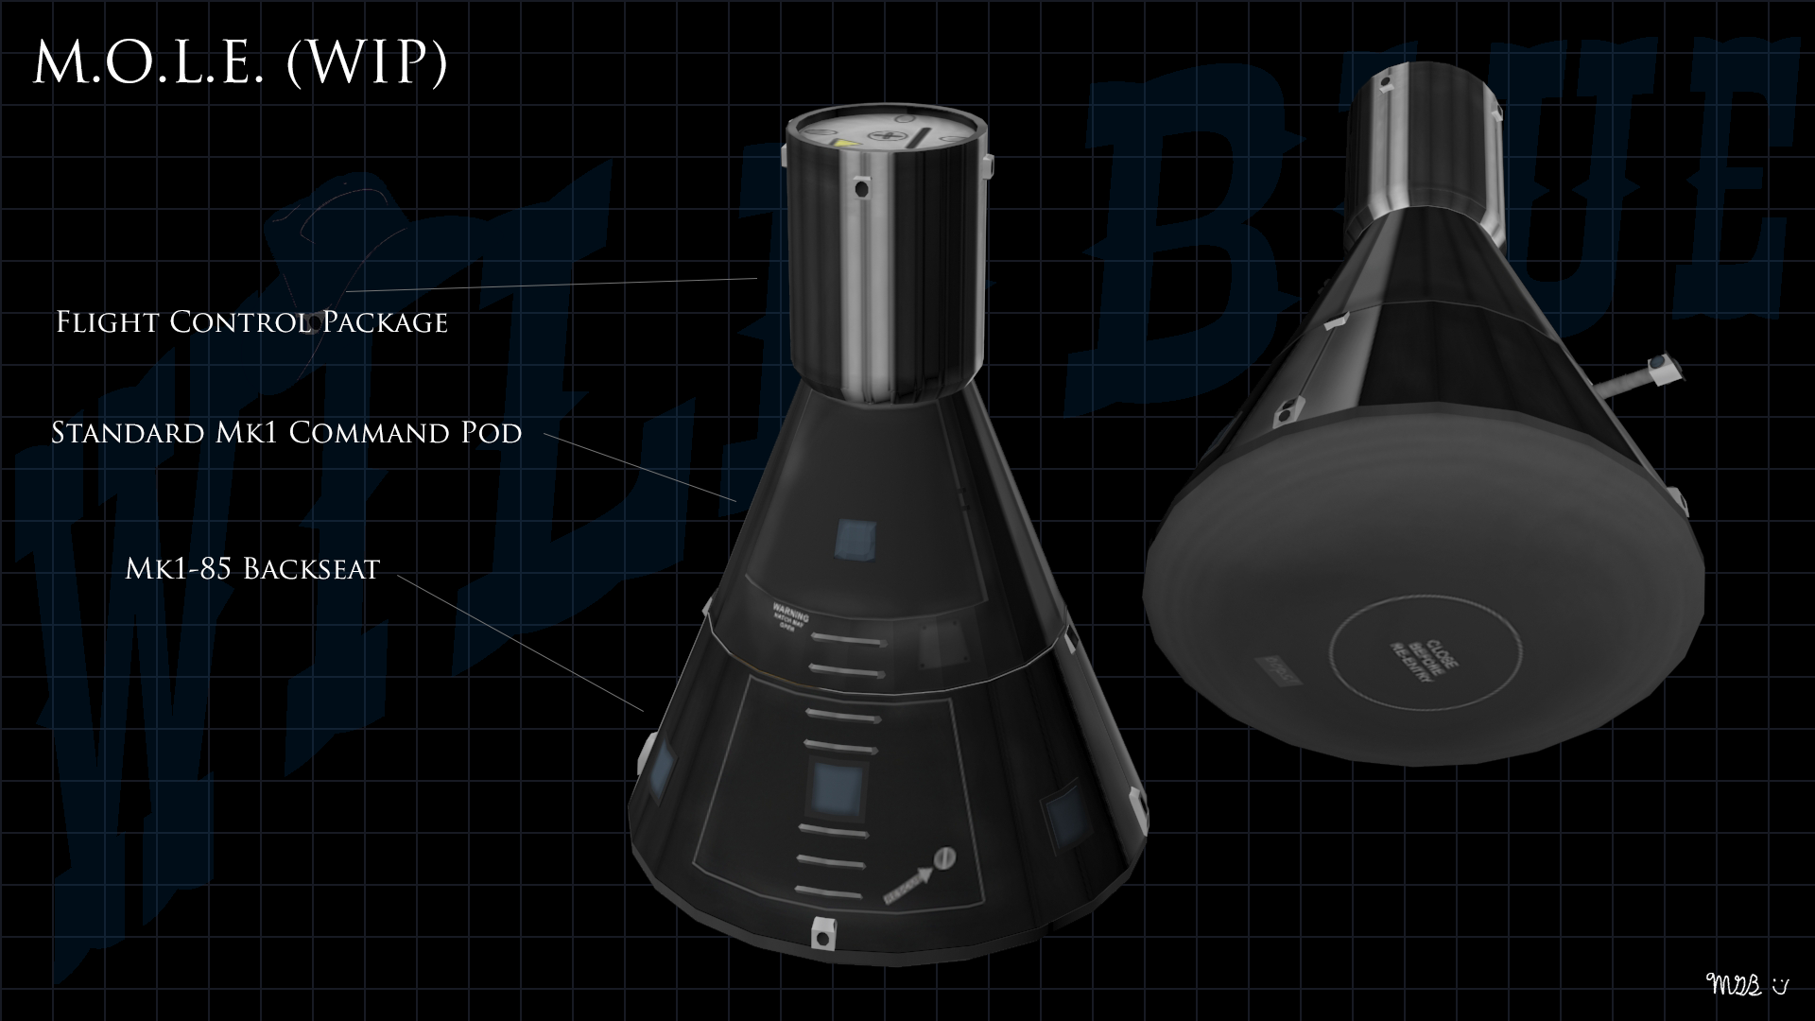  
  
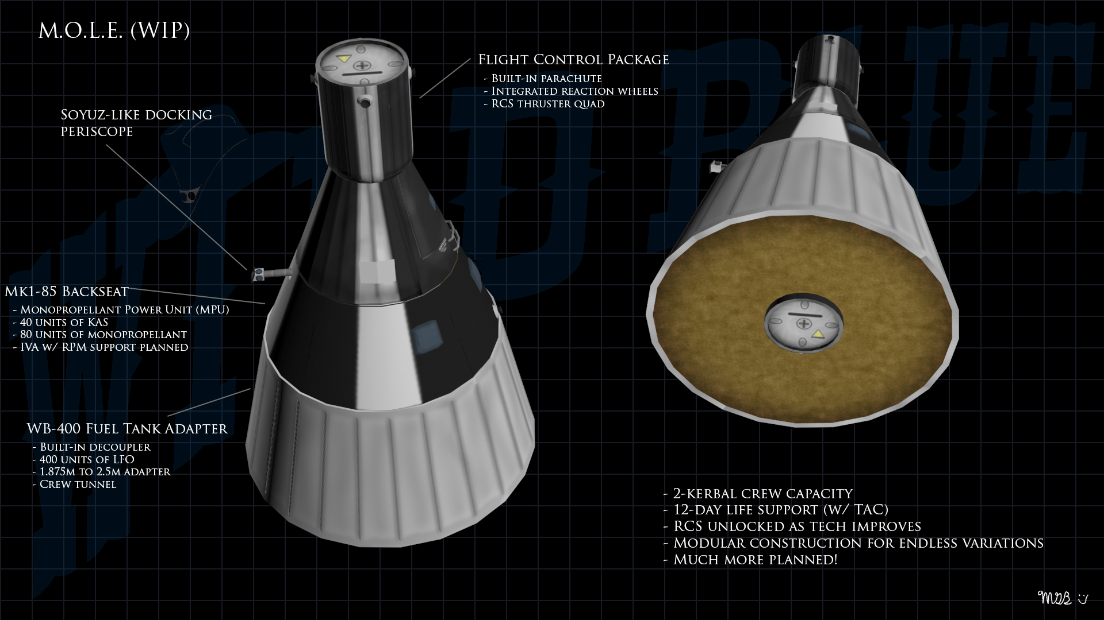  
Are your Mk1 command pods gathering dust? Wish you had a space station earlier in your career? Then the Mark One Laboratory Extensions (MOLE) are for you! Give your Mk1 command pod a new lease on life by adding a back seat module for an additional kerbal. Add a docking tunnel system with integrated RCS and parachute to making rendezvous and docking easier. With the Station Service Module, you’ll have additional life support (TAC-LS and Kerbal Snacks compatible), electrical power, and monopropellant. Add a Mark One Laboratory Extension for your experiments, and/or a DenEye Space Telescope for uh- astronomy! Yeah, that’s it!  
  
MOLE is a stand-alone parts pack with optional support for TAC Life Support, Kerbal Snacks, CactEye Telescope System, RealChutes, Deadly Reentry, and more.  
  
Inspiration  
Back in the 1960s, the USAF has a military space program, and one of its projects was the Manned Orbiting Laboratory (MOL). MOL was designed as a spy satellite (KH-10 Dorian) disguised as a military research station. One of the cool things about it is that the Gemini spacecraft was already attached to the station when it launched. The Air Force flew a mockup into orbit once, but then the program was cancelled.  
  
References  
<http://www.thespacereview.com/article/2539/1>  
<http://www.nationalmuseum.af.mil/factsheets/factsheet.asp?id=1647>  
<http://www.thelivingmoon.com/45jack_files/03files/MOL_Manned_Orbiting_Laboratory.html>  
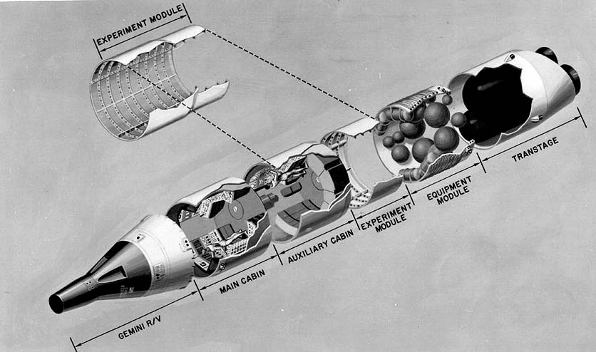  
  
[spoiler=ReadMe]  
Mark One Laboratory Extensions (M.O.L.E.)  
  
Are your Mk1 command pods gathering dust? Wish you had a space station earlier in your career? Then the Mark One Laboratory Extensions (MOLE) are for you! Give   
  
your Mk1 command pod a new lease on life by adding a back seat module for an additional kerbal. Add a docking tunnel system with integrated RCS and parachute to   
  
making rendezvous and docking easier. With the Station Service Module, you’ll have additional life support (TAC-LS and Kerbal Snacks compatible), electrical   
  
power, and monopropellant. Add a Mark One Laboratory Extension for your experiments, and/or a DenEye Space Telescope for uh- astronomy! Yeah, that’s it!  
MOLE is a stand-alone parts pack with optional support for TAC Life Support, Kerbal Snacks, Real Chute, Deadly Re-Entry, Regolith, CactEye Telescope System, and   
  
Multipurpose Colony Modules.  
  
Real World Inspiration  
  
Back in the 1960s, the USAF has a military space program, and one of its projects was the Manned Orbiting Laboratory (MOL). MOL was designed as a spy satellite   
  
(KH-10 Dorian) disguised as a military research station. One of the cool things about it is that the Gemini spacecraft was already attached to the station when   
  
it launched. The Air Force flew a mockup into orbit once, but then the program was cancelled.   
References  
<http://www.thespacereview.com/article/2539/1>  
<http://www.nationalmuseum.af.mil/factsheets/factsheet.asp?id=1647>  
<http://www.thelivingmoon.com/45jack_files/03files/MOL_Manned_Orbiting_Laboratory.html>  
  
  
---Installation---  
Copy the contents of the zip file to your GameData directory. Be sure to overwrite existing files and replace them.  
  
---REVISION HISTORY---  
0.1.2: Gemini At 50  
- Added the WBL-400 Adapter Tank. It fits on the back of the Backseat, carries LFO, has a built-in decoupler and built-in separatrons for stage separation.  
NOTE: RCS thrusters are a work in progress.  
  
0.1.1 Backseat Driver  
- Adds the Mk1-85 Backseat. It has optional support for Regolith (for the Monopropellant Power Unit), KAS, TAC Life Support, and Deadly Re-Entry.  
- Adds the SD-18 Decoupler Adapter. It comes in three different sizes. You can remove the decoupler from the staging list before launch.  
- The Flight Control Package now has optional support for RealChute.  
- Bug fixes  
  
0.1.0 Initial Release  
- Introduces the Mk1 Flight Control Package.  
  
---LICENSE---  
  
Source code copyrighgt 2014, by Michael Billard (Angel-125)  
License: CC BY-NC-SA 4.0  
License URL: <https://creativecommons.org/licenses/by-nc-sa/4.0/>  
Wild Blue Industries is trademarked by Michael Billard and may be used for non-commercial purposes. All other rights reserved.  
Note that Wild Blue Industries is a ficticious entity   
created for entertainment purposes. It is in no way meant to represent a real entity.  
Any similarity to a real entity is purely coincidental.  
  
THE SOFTWARE IS PROVIDED "AS IS", WITHOUT WARRANTY OF ANY KIND, EXPRESS OR IMPLIED, INCLUDING BUT NOT LIMITED TO THE WARRANTIES OF MERCHANTABILITY, FITNESS FOR A   
  
PARTICULAR PURPOSE AND NONINFRINGEMENT. IN NO EVENT SHALL THE AUTHORS OR COPYRIGHT HOLDERS BE LIABLE FOR ANY CLAIM, DAMAGES OR OTHER LIABILITY, WHETHER IN AN   
  
ACTION OF CONTRACT, TORT OR OTHERWISE, ARISING FROM, OUT OF OR IN CONNECTION WITH THE SOFTWARE OR THE USE OR OTHER DEALINGS IN THE SOFTWARE.  
[/spoiler]